


REGIONAL SEMINAR

ON RADIOACTIVE WASTE DISPOSAL

Hotel Senec****
Senec, Slovak Republic
October 8-9, 2013
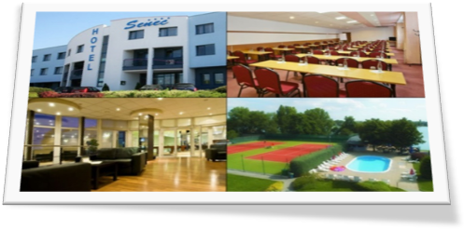

Last Announcement
&
Call for Papers

Organized by:
DECOM, a.s. and Slovak Nuclear Society
Background
16 years ago, the Czech and Slovak subjects involved in the geological disposal development programmes came to an arrangement of annual bi-lateral seminars on radioactive waste and spent fuel management, particularly its disposal in repositories. Since then, the seminar has spread wider to “Regional Central-European”, with participation of many renowned experts also from other countries. This year, the honour to hold the 16th Regional seminar has fallen to DECOM’s share.
The main objective of seminar is to provide a common platform for experts and decision makers to discuss policies and strategies for the safe management of RAW, examine possible approaches for disposal of RAW, share experiences and explore future directions. In spite of the differences between national concepts and status of particular programmes, many common problems can be identified. Sharing experiences and identification of commonalities should be a basis for closer co-operation of involved subjects within the region.
Seminar Location
The seminar will take place in the Hotel Senec****. It is a famous touristic destination located in western Slovakia that offers beautiful lakes, sport facilities and a number of attractions nearby. The town of Senec is easily reachable via highway, gateway airports are Bratislava (25 km) and Vienna (100 km).
Scope of Sessions
- New approaches in RAW/SNF management,
- Technical problems and achievements in design, siting and operation of RAW repositories,
- Public involvement aspects of RAW management.
General Information
The seminar will consist of oral presentations in English, no translations will be provided. All presentations are planned to be given in plenary sessions. Organizers will provide the seminar proceedings on CD-ROM for all participants. More information available at www.decom.sk/seminar.
Expenditures
The registration fee € 100 includes participation in sessions, special evening, lunch, dinner, break coffees as well as a copy of the proceedings.
Accommodation
Hotel reservation at Hotel Senec**** :
rezervacie@hotelsenec.sk
http://www.hotelsenec.sk/en

Key Dates
Deadline for receipt of registration form:
30 September, 2013
Deadline for receipt of electronic version of papers:
4 October, 2013
Program of Seminar
October 8 (Tuesday)
12:30 – 13:00 Registration, Hotel Senec ****
13:00 – 14:30 Technical Presentations I
14:30 – 14:50 Coffee Break
14:50 – 16:20 Technical Presentations II
18:00 – 22:00 Dinner (Special evening)
October 9 (Wednesday)
09:00 – 10:20 Technical Presentations III
10:20 – 10:40 Coffee Break
10:40 – 11:50 Technical Presentations IV
11:50 – 12:00 Closing of the Seminar

Map
