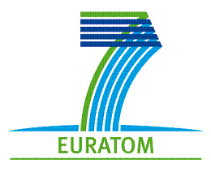

Independent Technical Expertise Interacting with Civil society on Radioactive Waste Management in Europe
A SITEX EUROPEAN WORKSHOP
Organised by the European Concerted action “Sustainable network of Independent Technical Expertise for radioactive waste disposal“ (SITEX)

16 - 17 September 2013,
Hotel Dolphin, Senec, Slovakia

Accommodation and travel information
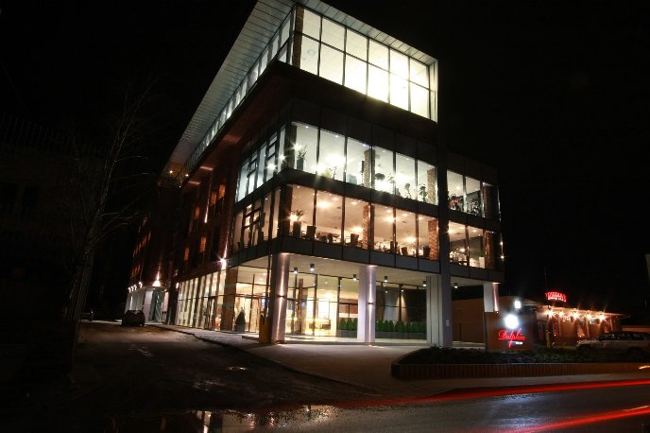
ACCOMODATION
Venue:
Hotel Dolphin****
Štefánikova 78
903 01 Senec, Slovensko
Tel.: +421 2 20 20 40 40
Fax: +421 2 20 20 40 41
info@hoteldelfin.sk
http://www.hoteldelfin.sk/en/

Price for workshop participants : 55,70 € / night
- rooms for workshop participants are prebooked for 2 nights (15-17 September),
- in the case of shorter/longer stay please indicate it via email
- 15 min walk from bus station, 10 min from train station
- Free parking
- Free internet, wi-fi in the lobby
- Aqua thermal park and lake resort in vicinity

LOCATION :
http://goo.gl/maps/Ez0cO
<https://maps.google.com/maps/ms?ll=48.21864,17.415347&spn=0.024734,0.055747&t=m&z=15&vpsrc=6&msa=0&msid=200447679813859491814.0004df069ac7f6d754d7d>

TRANSPORT

ARRIVAL BY PLANE
The nearest airport is the Bratislava airport, but there are only few lowcost flights with Ryanair.
The best option is to arrive to Vienna airport (Flughafen Wien, Schwechat)
Information on any public transport, including international connections :
http://cp.atlas.sk/bus/spojenie/

DEPARTURE FOR VIENNA AIRPORT WILL BE ORGANIZE ON TUESDAY, 17.9. AFTER WORKSHOP WITH ARRIVAL AT THE AIRPORT AT 18:00.

FROM VIENNA AIRPORT (Flughafen Wien, Schwechat) TO BRATISLAVA BUS TERMINAL (Bratislava, AS)

Vienna airport is cca 50 km from Bratislava. Travel by bus takes cca 60 minutes to the Bratislava bus terminal (Bratislava, AS), plus additional travel by bus to Senec.
Caution: there are 2 different bus companies from Vienna airport to Bratislava, and they can be confused. Only the Eurolines goes to the bus terminal, Blaguss goes to the Bratislava airport.

Slovak lines= Eurolines Slovakia = Postbus (more frequent, reservations recommended) - http://www.slovaklines.sk/index_en.html, http://www.oebb.at/busplan2013/119500.pdf

Departures on Sunday 15th September: 9:30, 10:30, ..., 23:30.
Look for your best connection at:
http://www.eurolines.sk/fileadmin/user_upload/cestovne_poriadky/mal/wien_new.pdf
You can buy the ticket (7,70 € ) from the driver either book it in advance.

Blaguss (less frequent) http://www.blaguss.sk/media/bratislava-vieden%20blaguss%2006.08.2012.pdf
If you chose the Blaguss bus, we recommend you to get off at the last stop, i.e. Bratislava airport.
– caution: tickets are sold only by bus driver.

Vienna airport map
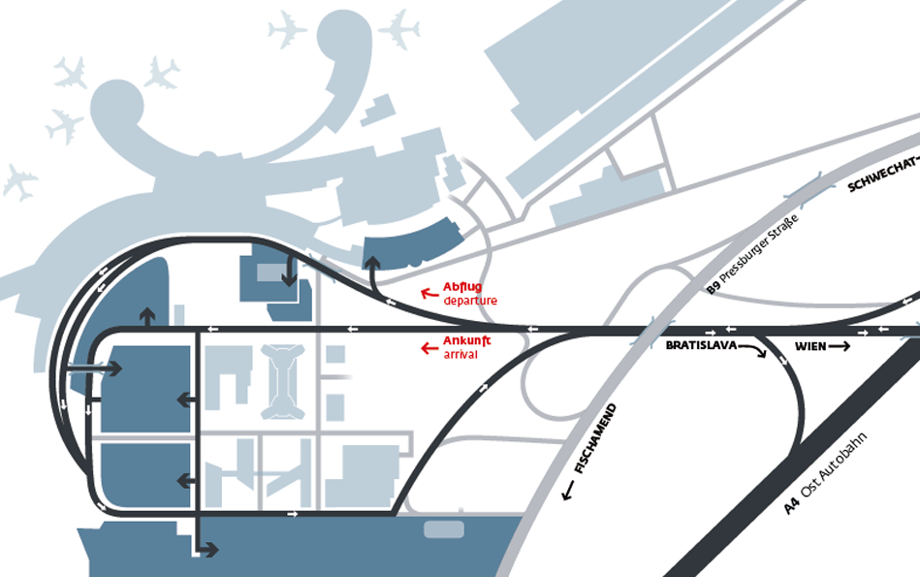

FROM BRATISLAVA BUS TERMINAL (Bratislava, AS) TO SENEC
There are few lines to Senec, in the bus terminal there is an information table with departures and platforms.
Local buses can have few stops in Senec, long distance buses stops only at bus station.
Tickets are sold by bus driver..

FROM BRATISLAVA AIRPORT TO SENEC

Take the public transport bus No. 61 to the train station (Bratislava - Hlavna stanica).
(http://imhd.zoznam.sk/ba/schedule-timetable/linka/61/smer/-/zastavka/-/734003295270.html)

Bus ticket you have to buy in the airport or in the bell-punch.

FROM BRATISLAVA STATION (Hlavna stanica) TO SENEC

The train to Senec departs once an hour (hh:07) usually, (direction Nove Zamky) (http://cp.atlas.sk/vlak/spojenie/).

