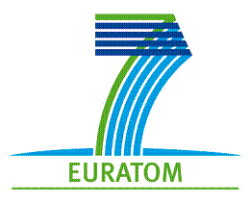
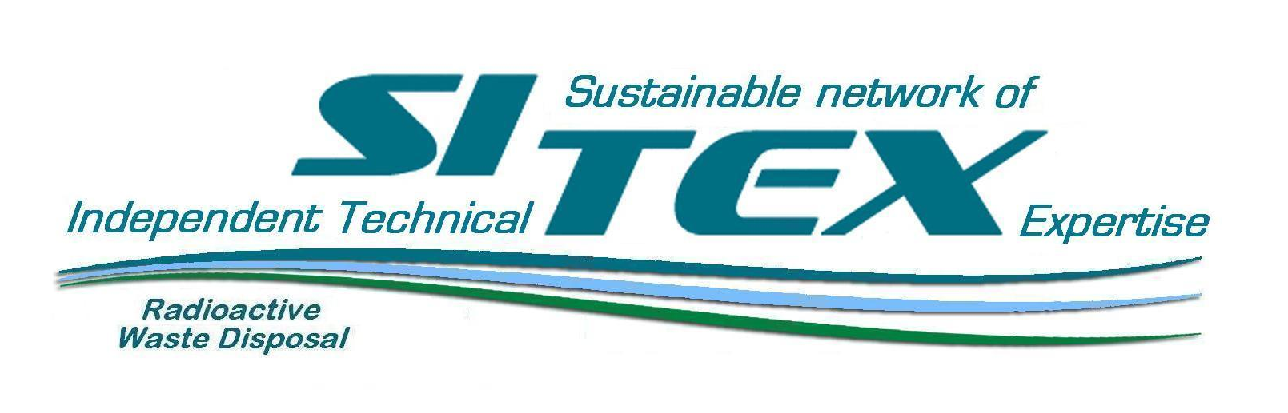

Independent Technical Expertise Interacting with Civil society on Radioactive Waste Management in Europe
A SITEX EUROPEAN WORKSHOP
Organised by the European Concerted action “Sustainable network of Independent Technical Expertise for radioactive waste disposal“ (SITEX)

16 - 17 September 2013,
Hotel Dolphin, Senec, Slovakia

FIRST ANNOUNCEMENT
May 24th, 2013

Context of the Workshop
Public information & participation in the context of Radioactive Waste Management (RWM) is a legal requirement in Europe embodied in several international frameworks, such as in the Council Directive 2011/70/EURATOM, in consistency with the terms of the Aarhus Convention (1998) now undersigned by some 40 European Countries together with the European Union. Provisions for transparency are also provided by the “Safety Case and Safety Assessment for the Disposal of Radioactive Waste“ (IAEA Safety Standards - Series N° SSG-23, 2012), as well as by the “Legal and Governmental Infrastructure for Nuclear, Radiation, Radioactive Waste and Transport Safety“ (IAEA SAFETY STANDARDS SERIES No. GS-R-1 , 2000). In addition legal provisions for Public Information and Participation are also provided at national level in several national legal frameworks for RWM.
Developing public access to information and participation in decision-making processes in the context of RWM requires interactions between expert organisations and the civil society. It is acknowledged that in each country both the regulatory authorities and the public require access to independent and knowledgeable expert resources. Independent expertise is typically provided by experts working within Regulatory Bodies and Technical Support Organisations (TSOs) as well as by academics, private consultants, foreign experts not engaged in the national context, civil society experts or any other independent experts. Various processes of interaction between experts and civil society have thus developed in Europe since the mid-1990’s, involving different types of experts. The considered processes, up to a certain extent, can represent an opportunity for civil society 1) to access different sources of expertise in order to enhance its technical knowledge & capacities, 2) to voice its concerns and values, 3) to influence the framing of the issues at stake in the expertise process, and to contribute to the quality of expertise.
SITEX is a European concerted action, which is supported by the European Commission DG RTD in order to investigate the need for a European network of independent expertise in RWM and corresponding needs regarding research. SITEX aims at identifying the efficient means that should be developed through the establishment of a sustainable expertise function network within a European framework with the view to sharing, where needed, expertise approaches with various stakeholders and more specifically with the civil society.

Objectives of the European Workshop
The purpose of the workshop is to investigate the possible interactions between the civil society and the several institutions bearing an independent expertise function regarding RWM. More specifically, the meeting will aim at :
- clarifying existing interactions between the civil Society (CS) and experts discussing practical case studies (in Germany, France and Czech Republic) in the context of RWM.
- discussing the initiative launched by SITEX to develop a sustainable network of independent expertise in RWM and possible options for further developing interactions between the civil society and the experts in the context of future RWM decision making processes in Europe (at local, national and European levels of decisions). Special attention will be devoted to the potential role of the public in the emerging structuration of the future development of European research on RWM (European Technological Platforms, IGDTP, SITEX).

Expected outcomes of the Workshop
The workshop will be an opportunity for experts and the civil society participants to develop a mutual understanding of the stakes associated with the development of Public Information and Participation in the perspective of the quality and the sustainability of RWM safety. The pluralistic review of the case studies is expected to feed the future reflection on the way to improve the quality of those interactions and the limits and pitfalls of existing processes. The SITEX partners will provide the participants with a review of their work regarding the characterisation of the expertise function in the European context (and abroad). The meeting will be an opportunity to identify the mutual needs regarding interactions between experts and civil society in the future along the decision-making processes of RWM and more specifically in the context of the implementation of geological disposal programmes.

PRELIMINARY WORKSHOP PROGRAM

First Day, 16th, September, 2013

8:30 |  | Registration and coffee
9:00 |  | Introduction and welcome, by the hosting organisation DECOM  Overview of the SITEX project, Christophe Serres
 |  | Introduction of the participants
 | 9:45 | Session 1 - Case study presentations & discussions
- The Asse citizen advisory group and expert advisory group process in Germany,

- The Group of Pluralistic Experts on the mining sites of uranium in Limousin, France
11:35 |  | Coffee and refreshments
12:05 |  | - The ARGONA Interaction Panel on “Siting and safety case” in the Czech Republic
13:00 |  | Lunch
14:30 |  | Session 1 (continued)  - Transversal discussion on the case study presentations (Plenary)
15:30 |  | Session 2 – Working Groups
What is the purpose of engaging the public in the expertise function?
- Improving the quality of expertise?
- Taking on board the values of the public in the expertise?
- Raising the knowledge and capacities of the stakeholders from the public?
- Creating opportunities for concerned members of the public to develop their own expertise?
- Improving the RWM Safety?
- Developing long-term societal vigilance on RWM?

17:00 |  | Reporting of the Working Groups in plenary
17:30 |  | End of the 1st day

19:00 | Social event

Second Day, 17th September, 2013
9:00 | Session 2 - Further developing interactions between civil society and experts in the context of RWM : discussing the SITEX proposals
Presentation of the “World Café“ participation principles

Presentation of Roundtable topics (plenary) :

- Roundtable I: What does expertise function mean (independency, transparency, competence)? - Christophe Serres, IRSN

- Roundtable II: The RWM decision making process, the role of the expertise function, possible interactions with the civil society, necessary conditions for allowing mutual understanding between experts and the civil society - Frank Lemy, FANC

- Roundtable III: The safety case review, possible interactions with the civil society - Muriel Rocher, IRSN

- Roundtable IV: The research agenda of the expertise function at national and European levels, discussing the expectations of the civil society - Venda Havlová, UJV

- Roundtable V: Mapping the potential opportunities for the public to interact with the RWM decision making process at local, national & European levels - Gilles Hériard-Dubreuil, Mutadis
09:50 | “World Café“ discussions in parallel roundtable groups
10:30 | Coffee break
 | “World Café“ (continued)
12:30 | Lunch
14:00 | Conclusions of morning session II  Report on the roundtables conclusions

15:00 | Session 3 Developing a European network of expertise function as a sustainable entity, foreseen interactions with the civil society

- The SITEX European network foreseen functions, potential interactions of SITEX with the civil society - Gilles Hériard Dubreuil, Mutadis
- The transformation of the European governance of RWM Research & Development, expected interactions with the civil society, perspective and questions, Stéphane Baudé – Mutadis
- Panel discussion with SITEX participants

16:30 | Conclusion of the meeting, Christophe Serres, IRSN
17:00 | Adjourn

SITEX PARTICIPANTS : INSTITUT DE RADIOPROTECTION ET DE SURETE NUCLEAIRE (IRSN) France, Federal Agency for Nuclear Control FANC (Belgium), GESELLSCHAFT FUER ANLAGEN- UND REAKTORSICHERHEIT (GRS), MBH GRS, Germany, USTAV JADERNEHO VYZKUMU REZ A.S. (UJV), Czech Republic, BEL V (Bel V), Belgium, LIETUVOS ENERGETIKOS INSTITUTAS (LEI), Lithuania, DECOM AS (DECOM), Slovakia, MINISTERE DE L'ECOLOGIE, DU DEVELOPPEMENT DURABLE DES TRANSPORTS ET DU LOGEMENT (ASN), France, STRALSAKERHETSMYNDIGHETEN (SSM), Sweden, MINISTERIE VAN ECONOMISCHE ZAKEN, LANDBOUW EN INNOVATIE (ELI), Netherlands, CANADIAN NUCLEAR SAFETY COMMISSION (CNSC-CCSN), Canada, MUTADIS CONSULTANTS SARL (MUTADIS), France, EIDGENOSSISCHES NUKLEARSICHERHEINSPEKTORAT ENSI (ENSI) Switzerland, NUCLEAR RESEARCH AND CONSULTANCY GROUP (NRG), Netherlands, EUROPEAN NUCLEAR SAFETY TRAINING AND TUTORING INSTITUTE (ENSTTI), France.
SITEX aims at identifying the efficient means that should be developed through the establishment of a sustainable expertise function network within a European framework with the view to: - allowing mutual understanding between regulatory bodies, TSOs and waste management organisations(WMOs) on (i) the regulatory expectations at decision holdpoints and (ii) how the scientific and technical elements carried out by the WMOs comply with these expectations. In that perspective, the needs in clarification of existing regulatory guidance or in developing new guidance will be addressed. - in coordination with or in complement to WMO's research program, defining TSO's R&D program that would ensure independent capabilities development for reviewing the Safety Case and assessing the scientific arguments provided by WMOs. TSO's R&D program and priorities will be addressed by favouring close interaction with IGD-TP and seeking for joined research activities with the WMOs in order to foster common understanding of technical key points for safety and avoiding undue duplication; - ensuring competence building of experts in charge of technical review and transfer of knowledge on waste safety and radiation protection; the needs in guidance development for harmonising the technical review activity and in dedicated training and tutoring for spreading the expertise culture and practices will be addressed; - sharing, where needed, expertise approach with various stakeholders, in a manner more integrated than when only communication or dissemination are envisaged. Compilation of past actions and learning of ways of implication of stakeholders in the process of technical review will be discussed.

